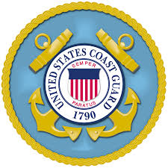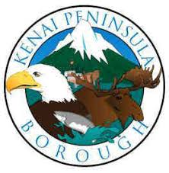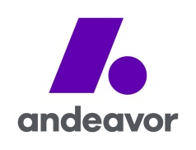

PRESS RELEASE

FOR IMMEDIATE RELEASE

DATE: November 2, 2017

MEDIA CONTACT: Joint Information Center
(907) 776- 7431

UNIFIED COMMAND RESPONDING TO ANDEAVOR TANK 2407 CRUDE DISCHARGE

KENAI, AK -- A Unified Command consisting of the United States Coast Guard, Alaska Department of Environmental Conservation, Kenai Peninsula Borough, and Andeavor Logistics is responding to a crude spill near the Andeavor refinery in Nikiski.

Andeavor Logistics can confirm that the spill is a result of a crane making impact on the North East side of Tank 2407, resulting in dike wall damage and product flowing into the roadway. The tank was full at 225,000 bbls of Alaska North Slope crude.

At this time, the Alaska State Troopers have closed the Kenai Spur Highway from the Nikiski Recreation Center to the Agrium plant. Alternate routes are required.

Enstar Natural Gas has shut down gas supply to Nikiski due to high pressure at the Bernice Lake Regulator Station. Approximately 900 homes are without heat at this time. The public should not try to turn on their own gas.

The Unified Command priorities are to ensure and protect the safety of citizens and response personnel while maximizing protection of the environment, containing the spill and maximizing product recovery.

For all other information related to the spill, the public is encouraged to watch the website www.response.tank2407release.com or call the Tank 2407 Crude Discharge hotline at 1-800-555-5555. Insurance claim information is forthcoming and will be distributed on the website and through the media.

