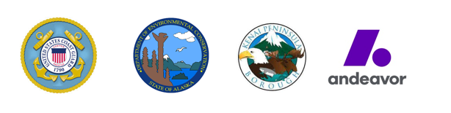
MEDIA ADVISORY

FOR IMMEDIATE RELEASE

DATE: November 2, 2107

CONTACT: Joint Information Center
(907) 776-7431

UNIFIED COMMAND TO HOLD PRESS CONFERENCE
REGARDING tank 2407 Crude Discharge

WHAT: The Tank 2407 Crude Discharge Unified Command will hold a press conference at 3:00pm on November 2, 2017 at Old Fire Station #1 to discuss response efforts.

Representatives of the Unified Command will offer brief remarks and take questions from credentialed members of the media. The press conference will end at 3:30 p.m.

WHEN: 3:00 p.m. UTC, Thursday, November 2, 2017

WHERE: Old Fire Station #1
44800 Kenai Spur Hwy
Nikiski, AK 99635

SPEAKERS: CDR James Binniker (Federal On-Scene Coordinator, United States Coast Guard)
Scott Rosin (Incident Commander, Andeavor)
Geoff Merrell (State On-Scene Coordinator, ADEC)
Scott Walden (Local On-Scene Coordinator, KPB OEM)

Please visit www.response.tank2407release.com for incident response information.

###

____ Legal ____ LOSC
____ SOSC ____ IC

