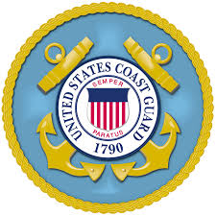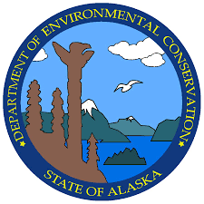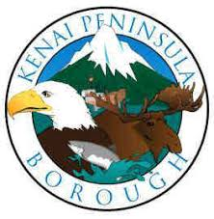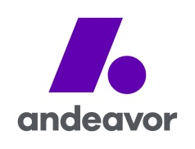

INTITAL NEWS RELEASE OR HOLDING STATEMENT

Date: November 2, 2017
Contact: Joint Information Center, (907) 776-7431

(Kenai, AK)- A Unified Command consisting of the US Coast Guard, Alaska Department of Environmental Conservation, Kenai Peninsula Borough, and Andeavor is responding to an oil spill in the Bernice Creek and Bernice Flats area of the Kenai Spur Highway.

At this time, the discharge continues, but will be brought under control as quickly and safely as possible. Response equipment is en route.

The Unified Command’s first priority is for the safety of the community and our emergency responders. Requisite emergency responders and agencies have been notified. There is no additional information available at this stage, but every effort is being made to confirm details quickly.

The Unified Command is committed to an efficient, proactive and coordinated response and is requesting that citizens refrain from visiting the scene so that crews can safely perform response activities. Additional information will be forthcoming as more details are gathered.

Members of the media may call or email the Andeavor Media line at 210-626-7702 or media@andeavor.com for information.

###

____ Legal
____ SOSC

____ LOSC

____ IC

